**A Comprehensive Analysis of Financial Performance Insights from a Leading Banks**

# **1.Introduction**

* 1. **Overview**

This session introduces bank financial statements and provides a traditional, ratio-based procedure for analysing bank financial performance using historical data. It demonstrates the interrelationship between the income statement and balance sheet and describes the risk and return trade-off underlying management decisions. Data are provided that compare the performance characteristics of small banks versus large banks and differentiate between high and low performers.

# **1.2 Purpose**

Financial performance analysis includes analysis and interpretation of financial statements such a way that it undertakes a full diagnosis of the profitability and financial soundness of the business. The financial analyst program provides vital methodologies of financial analysis.

# **2.Problem Definition & Design Thinking**

# **2.1 Empathy Map**

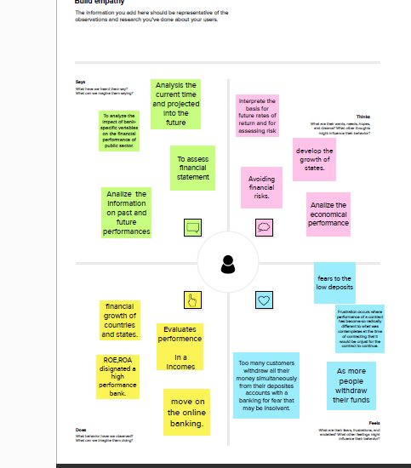

# **2.2 Ideation & Brainstroming Map**



# **3.Result**

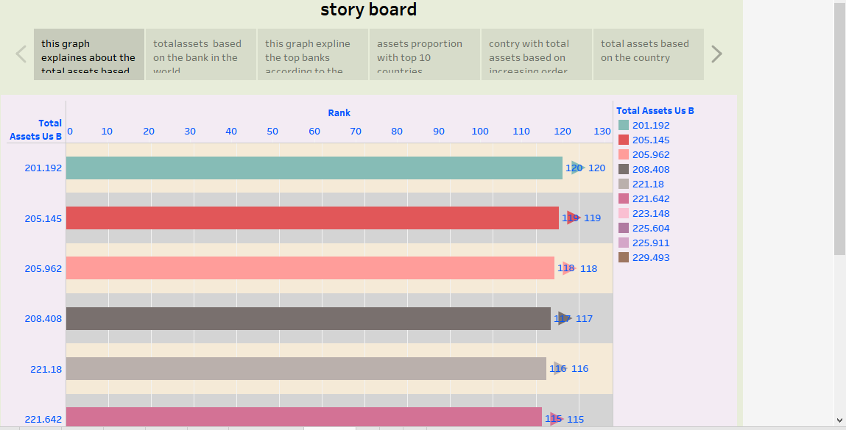

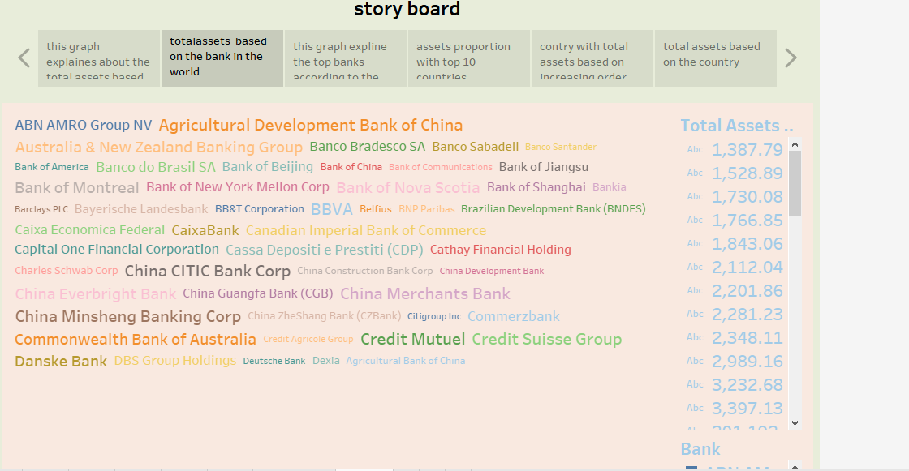

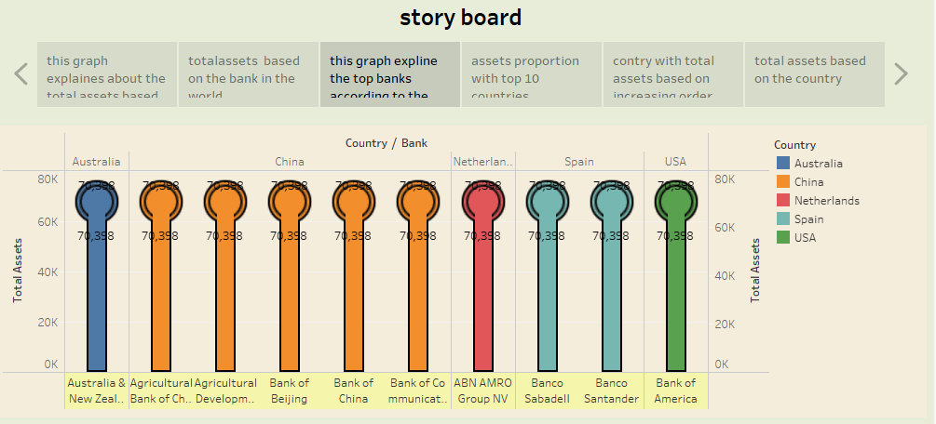

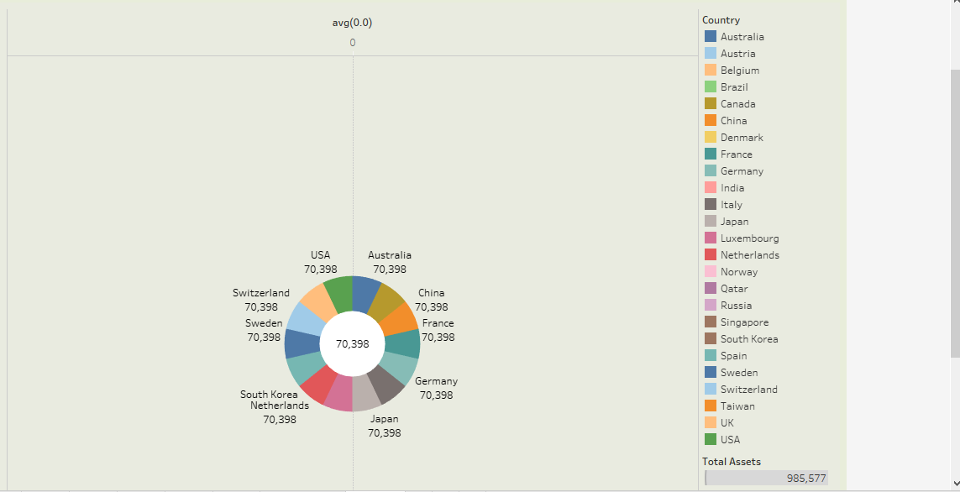

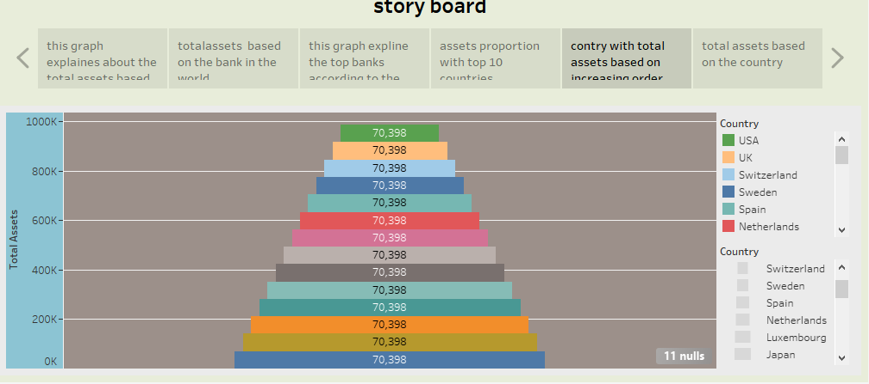

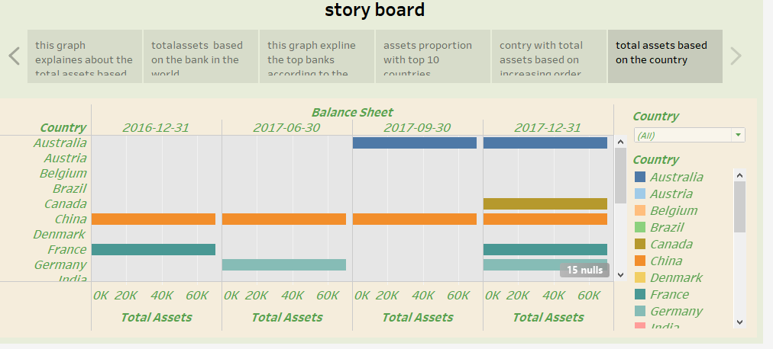

# **4.Advantages and Disadvantages**

# **Advantages**

**Here are some of the important advantages of financial performance analysis.**

* Assess the Financial Health of a Bank.
* Identify Areas for Improvement.
* Monitor Performance.
* Communicate Financial Information.
* Income Statement.
* Balance Sheet.
* Cash Flow Statement.
* Profitability Ratios.

# **Disadvantages**

**Limitations of financial statements**

* Do Not Contain Some Intangible Assets.
* Only Cover a Specific Period of Time.
* May Not Be Comparable.
* Could be Wrong Due to Fraud.
* Do Not Cover Non-Financial Issues.

# **5. Applications**

Financial analysis is used to evaluate economic trends, set financial policy, build long-term plans for business activity, and identify projects or companies for investment. This is done through the synthesis of financial numbers and data.

  Applications of financial statement analysis, including the evaluation of past financial performance, the projection of future financial performance, the assessment of credit risk, and the screening of potential equity investments.

# **6. Conclusion**

 Analysis of financial statements is extremely important for every bank to grow and increase. It should not be compromised since it increases the efficiency of bank operations. Better processes and expert analysts can help in the detailed analysis process.

# **7. Future Scope**

Analyse financial ratios to assess profitability, solvency, working capital management, liquidity, and operating effectiveness. Compare current performance with historical conditions using trend analysis. Compare with another banks to find out how well banks are performing financialy.